How to Respond to a Story on Care Opinion

Requirements for posting a response:
1. To post a response, you must be a member of a subscription on Care Opinion and have responding access.
2. You must be logged into your Care Opinion account.
How to respond to a story on Care Opinion
1: Log into Care Opinion (click log in in the top right of the website) or if you have clicked a link in an email alert from Care Opinion you will be automatically logged in the first time.
2: go to the story you want to respond to and scroll to the bottom of the page. There will be a response box.
3: Write your reply as you would like it to appear on the Care Opinion website.

If the box isn’t there, check that the 2 key requirements for posting a response have been met (see above). An easy way to know that you are not logged in, is to check for the green navigation drawer in the top left hand corner of the page, if the green box is not there, then you are not logged in.
The response box will look like this:
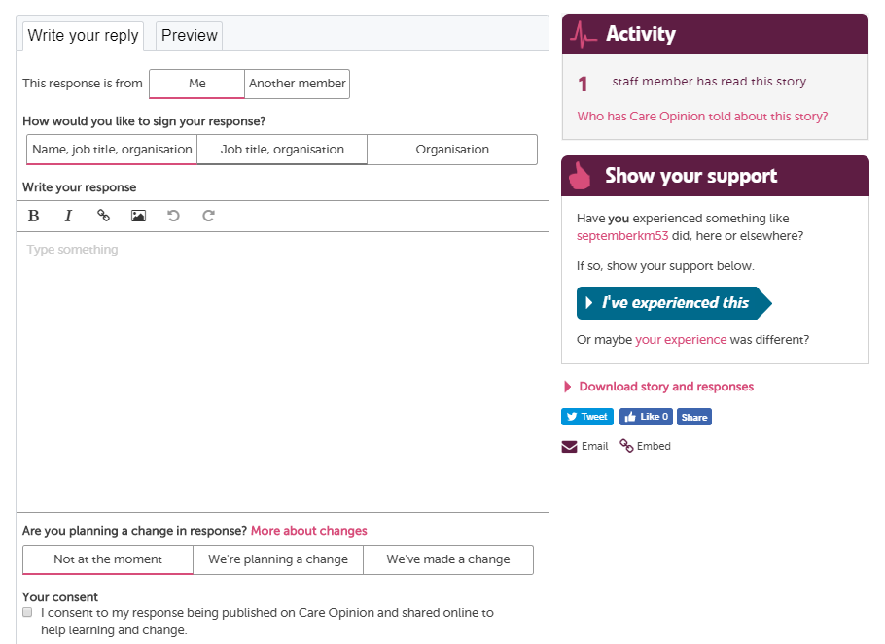

Signing your response
You can then choose how you would like to sign your response (note that this appears at the top of your response and so we recommend signing off your response in the text box also). You can choose from 3 options of how to sign off your response depending on how personal you would like your reply to be. We recommend the default option as it is more personal – Name, job title, organisation. If you have uploaded a profile picture we will show this is you use your name.

Additional formatting in your response
You can use the buttons to change text to bold or italics. You can add pictures or links here too. We have some helpful guidance for writing your response above the response box. Click the pink links to view, or join one of our webinars for more advice.
Showing that you are making a change
You have the option to add a marker to your response showing that you are planning to make a change/ that you have made a change because of the feedback in the story that you are responding to. If there is no change, then you don’t need to do anything as the “not at the moment” option is set as the default. You can always post a further response in the future if anything changes.
Submit your response
To submit your response we ask for you to consent to your response being published on the site, simply tick the box, then click “send your response”. You have 30 minutes to make any edits to your response.
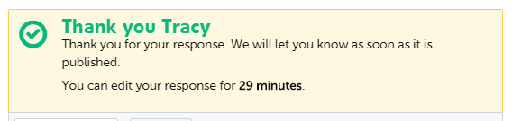

Moderation
Once you have submitted your response you will see a green tick. This means that we have received your response. When you start using Care Opinion, your response will be read and approved by one of our moderators. When you are more confident with Care Opinion responses will be automatically approved. This means they will be published after half an hour editing window has closed.
You will receive an email informing you your response has been published and we will also automatically email the author of the story to let them know that their story has a response.

If you require any further help or advice, please contact Care Opinion by phone or email.

Guidance for writing a response: What to include
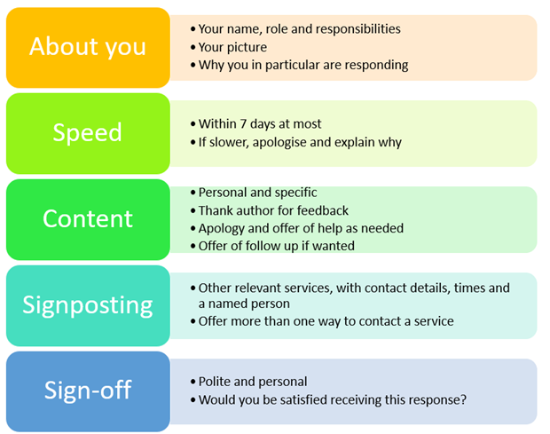
New research based on Care Opinion stories and responses has identified the five most important features to include in a helpful Care Opinion response. See the five features detailed in the table below. If you'd like more help or advice with responding to stories on Care Opinion, why not join our next "How To" webinar session, where we'll discuss different examples of responses and best practice. The session is part of our ongoing webinar programme, simply click the link to view the upcoming dates and register to join.

